Bahria University,

Karachi Campus



LAB EXPERIMENT NO.

**02**

LIST OF TASKS

|  |  |
| --- | --- |
| TASK NO | OBJECTIVE |
| 1 | **Write a Python program that calculates the absolute as well as relative error present in the following measurements: Actual values: [11.0098, 167.902, 56.0567, 67.9860] Measured values: [12.0001, 166.802, 55.0001, 69.0000]** |
| 2 | **Write a Python program the find the propagated error in the area and perimeter found for the following measurements: -  SQUARE (length : 45.09 cm ; uncertainty : 0.01 cm) - CIRCLE (radius : 34.90 cm ; uncertainty : 0.05 cm) - TRIANGLE (side1 : 70.9 m ; uncertainty : 0.23 m, side2 : 89.07cm ; uncertainty : 0.07 m, base : 76.07cm ; uncertainty : 0.04 m, height : 100.07cm ; uncertainty : 0.05 m) - TRAPEZIUM(side1 : 670.9 m ; uncertainty : 0.53 m (parallel one), side2 : 849.07cm ; uncertainty : 0.27 m (parallel one) side3 : 376.07cm ; uncertainty : 0.74 m, side4 : 716.07cm ; uncertainty : 0.14 m, height : 231.07cm ; uncertainty : 0.25 m)** |
| 3 | **Write a Python program that calculates the square root of following numbers using both the math.sqrt function (which uses floating-point arithmetic) and a custom square root function that uses integer arithmetic. Then, find and compare the results to observe the rounding error. (56.90, 100.45, 67.90, 25.67, 56.67)** |
| 4 | **Write a python program which finds the value of PI (π) using Taylor series, and then find the truncating error occurred due to the use of finite number of terms. HINT: arctan (1) = π/4, and formula for finding Tylor series for arctan is: 𝐚𝐫𝐜𝐭𝐚𝐧(𝐱) = ∑ (−1) 𝑛𝑧 2𝑛+1 2𝑛+1 ; ∞ 𝑛=0 |z| ≤ 1, z ≠ i, i** |

**Task 1: Write a Python program that calculates the absolute as well as relative error present in the following measurements: Actual values: [11.0098, 167.902, 56.0567, 67.9860] Measured values: [12.0001, 166.802, 55.0001, 69.0000]**

**Solution:**

**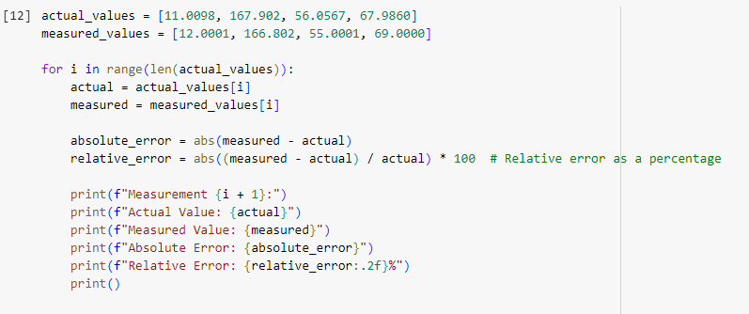  
**

**Task 2: Write a Python program the find the propagated error in the area and perimeter found for the following measurements:  
  
 - SQUARE (length : 45.09 cm ; uncertainty : 0.01 cm)   
- CIRCLE (radius : 34.90 cm ; uncertainty : 0.05 cm)   
- TRIANGLE (side1 : 70.9 m ; uncertainty : 0.23 m, side2 : 89.07cm ; uncertainty : 0.07 m, base : 76.07cm ; uncertainty : 0.04 m, height : 100.07cm ; uncertainty : 0.05 m)  
-TRAPEZIUM(side1 : 670.9 m ; uncertainty : 0.53 m (parallel one), side2 : 849.07cm ; uncertainty : 0.27 m (parallel one) side3 : 376.07cm ; uncertainty : 0.74 m, side4 : 716.07cm ; uncertainty : 0.14 m, height : 231.07cm ; uncertainty : 0.25 m)**

**Solution:**import math

def propagated_error(value, uncertainty):

    return value * uncertainty

# Square

length = 45.09

uncertainty_length = 0.01

perimeter_square = 4 * length

area_square = length * length

propagated_error_square_perimeter = propagated_error(4 * length, uncertainty_length)

propagated_error_square_area = propagated_error(2 * length, uncertainty_length)

# Circle

radius = 34.90

uncertainty_radius = 0.05

perimeter_circle = 2 * math.pi * radius

area_circle = math.pi * radius**2

propagated_error_circle_perimeter = propagated_error(2 * math.pi * radius, uncertainty_radius)

propagated_error_circle_area = propagated_error(2 * math.pi * radius**2, uncertainty_radius)

# Triangle

side1 = 70.9

side2 = 89.07

base = 76.07

height = 100.07

uncertainty_side1 = 0.23

uncertainty_side2 = 0.07

uncertainty_base = 0.04

uncertainty_height = 0.05

perimeter_triangle = side1 + side2 + base

area_triangle = (base * height) / 2

propagated_error_triangle_perimeter = propagated_error(side1 + side2 + base, uncertainty_side1 + uncertainty_side2 + uncertainty_base)

propagated_error_triangle_area = propagated_error((base * height) / 2, (uncertainty_base * height) + (uncertainty_height * base))

# Trapezium

side1 = 670.9

side2 = 849.07

side3 = 376.07

side4 = 716.07

height = 231.07

uncertainty_side1 = 0.53

uncertainty_side2 = 0.27

uncertainty_side3 = 0.74

uncertainty_side4 = 0.14

uncertainty_height = 0.25

perimeter_trapezium = side1 + side2 + side3 + side4

area_trapezium = ((side1 + side2) / 2) * height

propagated_error_trapezium_perimeter = propagated_error(side1 + side2 + side3 + side4, uncertainty_side1 + uncertainty_side2 + uncertainty_side3 + uncertainty_side4)

propagated_error_trapezium_area = propagated_error(((side1 + side2) / 2) * height, (0.5 * uncertainty_side1 * height) + (0.5 * uncertainty_height * (side1 + side2)))

# Display results

print("Square:")

print(f"Perimeter: {perimeter_square} cm, Propagated Error: {propagated_error_square_perimeter} cm")

print(f"Area: {area_square} cm^2, Propagated Error: {propagated_error_square_area} cm^2\n")

print("Circle:")

print(f"Perimeter: {perimeter_circle} cm, Propagated Error: {propagated_error_circle_perimeter} cm")

print(f"Area: {area_circle} cm^2, Propagated Error: {propagated_error_circle_area} cm^2\n")

print("Triangle:")

print(f"Perimeter: {perimeter_triangle} cm, Propagated Error: {propagated_error_triangle_perimeter} cm")

print(f"Area: {area_triangle} cm^2, Propagated Error: {propagated_error_triangle_area} cm^2\n")

print("Trapezium:")

print(f"Perimeter: {perimeter_trapezium} cm, Propagated Error: {propagated_error_trapezium_perimeter} cm")

print(f"Area: {area_trapezium} cm^2, Propagated Error: {propagated_error_trapezium_area} cm^2")

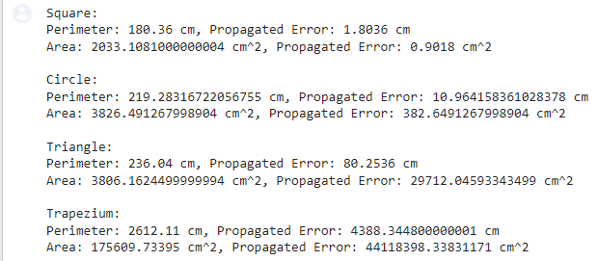

**Task 3: Write a Python program that calculates the square root of following numbers using both the math.sqrt function (which uses floating-point arithmetic) and a custom square root function that uses integer arithmetic. Then, find and compare the results to observe the rounding error.  
(56.90, 100.45, 67.90, 25.67, 56.67)**

**Solution**

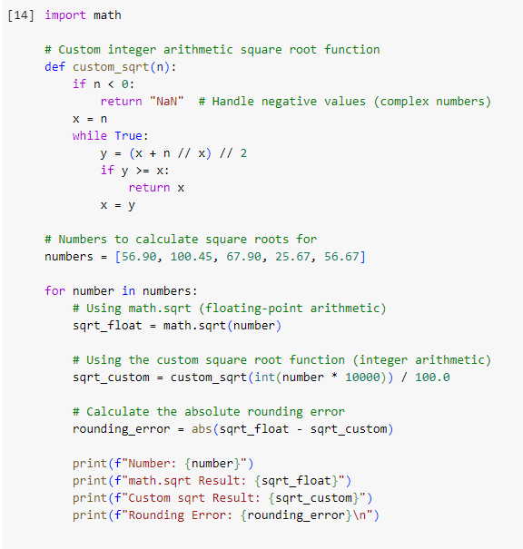

**Task 4: Write a python program which finds the value of PI (π) using Taylor series, and then find the truncating error occurred due to the use of finite number of terms. HINT: arctan (1) = π/4, and formula for finding Tylor series for arctan is: 𝐚𝐫𝐜𝐭𝐚𝐧(𝐱) = ∑ (−1) 𝑛𝑧 2𝑛+1 2𝑛+1 ; ∞ 𝑛=0 |z| ≤ 1, z ≠ i, i  
  
